

Wait Zar user's guide version 1.7

Table of Contents

1. Introduction p. 2
2. Requirements p. 2
3. Basic Usage p. 2
3.1 Switching from Myanmar to English p. 3
3.2 Typing Words in Myanmar p. 3
3.3 Pat-Sint Words p. 4
3.4 System Tray Icon p. 5
3.5 Blog Sticker p. 6
4. Finding a Word p. 6
4.1 The WaitZar Romanisation p. 6
4.1.1 Default Romanisation p. 7
4.1.2 Special Romanisations p. 10
4.1.3 Shortcuts p. 12
4.2 Dictionary Lookup p. 12
5. Advanced Usage p. 14
5.1 Changing the Hotkey p. 14
5.2 Configuration Options p. 15
5.2.1 Standard Options p. 15
5.2.2 Advanced Options p. 16
5.2.3 Deprecated Options p. 18
5.3 Changing the Font p. 18
5.4 Adding Your Own Words p. 19
5.5 Loading a Completely Different Language p. 20
5.6 Running Wait Zar from a USB Drive with PStart p. 21
6. Troubleshooting FAQ p. 23
6.1 A Note About Windows 7 p. 24
6.2 Known Font Issues p. 25
6.3 Contact the WaitZar Team p. 26
Appendix A: License p. 26
Appendix B: How It Works p.
1. Introduction

Welcome to Wait Zar, a syllable-level romanised input system for the Burmese language. Thanks for downloading this software; please go to:
http://code.google.com/p/waitzar/
...for the latest version of Wait Zar, or if you'd like to join the project. If you’d like to receive emails whenever Wait Zar is updated, please subscribe to our mailing list:
http://groups.google.com/group/waitzar
Wait Zar is a community project. It is open-source, and free. (This user’s guide was typed using Wait Zar in Microsoft Word.)

2. Requirements

Wait Zar is tested on Windows 2000, Windows XP, and Windows Vista. (It is known to work on Windows 7). It should work on these operating systems without any problems. If you are running another configuration (such as Windows Server 2003) and you experience an error, please post a bug report and we will look into it:
http://code.google.com/p/waitzar/issues/entry
You don't need anything else to run Wait Zar. It is designed to be usable from systems you don't have control over, like Internet Cafe or Library computers. You don't even need any Myanmar fonts; you will still be able to see the words as you type them. However, if you can install fonts, you should install whichever ones you plan on using. Currently supported fonts are:
- Zawgyi-One
- Win Innwa
- Padauk
- Parabaik
- Myanmar 3
We have included the Padauk font with this release of WaitZar; you should install Padauk in order to view this document properly.

3. Basic Usage

This section will describe how to use Wait Zar. After reading this, you will be able to type emails to your friends in Myanmar. To learn everything else, read the sections “Finding a Word” and “Advanced Usage”. If you really want to know everything, read the appendix “How it Works”.
To get started, download the latest version of Wait Zar and double-click “WaitZar.exe”. (You don't have to unzip it.) A blue icon with a white “!” will appear on your status bar, wait for it to change into the letters “ENG” —at this point, Wait Zar is ready to use!

3.1 Switching from Myanmar to English

Initially, Wait Zar will start in “English” mode. Your computer will work just like before, except that pressing the “Ctrl” and “Shift” keys at the same time will switch you to “Myanmar” mode. You can tell when this happens because the “ENG” icon will change to “မြ”. Hit “Ctrl” and “Shift” again to switch back to English.

3.2 Typing Words in Myanmar

Typing a word is accomplished by typing how that word sounds, and by following some simple rules (see Section 4 for more details). For most words, you can easily guess what you need to type. For example, to type “ko”, just type “k” then “o”. You'll see:
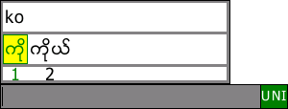
You can drag this window to a better location if you want. Pressing “space” or “enter” will choose the word in green. You can press “left” or “right” to change which word is selected. Pressing the number below a word is a shortcut to choosing that word (e.g., pressing “2” will type “ကိုယ်”). Pressing “escape” will cancel the current word.
After hitting “space”, “enter”, or a number key, you’ll notice that the “sentence window” is still visible:
The sentence window gathers words you’ve typed and permits very simple editing of phrases prior to actually typing them. It also tries to predict which Burmese word you want when you type, e.g., “pat” —there are eight possibilities! It does this by looking at the previous three words you’ve typed. This is useful, because if Wait Zar guesses correctly (and puts the word in place “1”), you only have to press “space” —no arrow or number keys are required.
Whenever only the sentence window is visible, the following controls apply:
- Pressing left/right will move the cursor (black bar) in the sentence window. The cursor is a “smart cursor”; it will move one word (not letter) each time you press left/right.
- Pressing a letter key will open the main window, and allow you to type another word. This word will appear at the current cursor position.
- Pressing “backspace” or “delete” will remove the word before or after the cursor, respectively. This allows you to fix minor problems in your sentence before committing it.
- Pressing a number key (0-9) will type the burmese numeral (၀-၉) into the sentence window.
- Pressing most symbol keys will type that symbol; this is designed to make regular typing much simpler. Currently, the following symbols are captured:
`~!@#$%^&*()-_=+[{]}\\|;:'\"<>/?
- Pressing “Enter” will “commit” the sentence, transferring it to the current active program (e.g., Microsoft Word).
- Pressing “space” will do the same thing, if the cursor is at the end of the sentence. If not, “space” will do the same thing as the “right” arrow key.
- Pressing “,” or “.” will “commit” the sentence, and then type “၊”or “။”.
- Pressing “F1” will bring up a virtual keyboard, and will allow you to look up a word’s romanisation by typing that word letter-by-letter.

3.3 Pat-Sint Words

Typing pat-sint words (e.g., “မန္တလေး”) is very easy in WaitZar. Simply type the first part of the word: “man” and hit “space” to send it to the sentence window. Then, type the stacked letter (and any trailing characters) —in this case, “ta”. Don’t hit space yet:
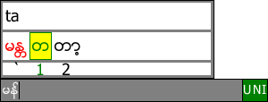
WaitZar has added a new entry, to the left of the “1” key. This new entry will combine with “man” to make “manda”. Since this is a special case, we have assigned it to a special key: the “~” key (left of the “1” key). We have also made “1” the default, to avoid confusing new users. Press “left” and the cursor will move to this special word:
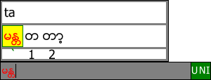
As you can see, the word “man” in the sentence window” has also turned red, and changed to “manda”. This indicates that pressing “space” will overwrite the previous word, which is exactly how pat-sint words usually work. Press “space” now (you could also press “`” or “~”). Now, you can continue to type the remainder of the word:
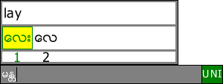
If you prefer, you can also type the pat-sint portion of the word as “manda” —see Section 4.1.2 for details.
As of WaitZar 1.7, this feature is still experimental. That means that not every pat-sint word can be typed using the shortcut notation.

3.4 System Tray Icon

Wait Zar will load an icon into your system tray. It will appear as either “ENG” or “မြ”, depending on the language you are typing in. If you right-click on this, you will see several options:
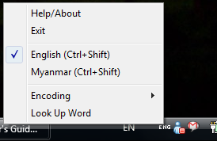
Help/About — Show basic information about the software.
Exit — Close Wait Zar. Removes all hotkeys from the system. If WaitZar.exe causes your system to slow down or behave strangely, choose this option to stop the program.
English — Change text mode to English. Same effect as pressing “Ctrl+Shift”
Myanmar — Change text mode to Myanmar. Same effect as pressing “Ctrl+Shift”
Encoding — Changes the character encoding of text output by Wait Zar. Set to “Unicode 5.1” by default; you can change this to type text in “Win Innwa” or “Zawgyi-One” if you prefer these fonts.
Look Up Word (F1) — If you don’t know how to type a difficult word, you can click this option to bring up the virtual keyboard. See Section 4.2 for details regarding this feature.

3.5 Blog Sticker

Show your support for Wait Zar! If you use Wait Zar to type your blog entries or forum posts, you can link to this image in your sidebar, and help spread the word about Wait Zar:

You can download this image from: http://waitzar.googlecode.com/files/wz_usericon.png

4. Finding a Word

Although WaitZar was designed to be natural to use, there will come a time when you do not know how to type a word in WaitZar. Fortunately, as of release 1.6 on Windows (and 1.0.0 on Linux), WaitZar now ships with version 2.0 of the WaitZar romanisation. This romanisation was designed to be simple and effective, and to make looking up unknown words easy. Version 1.7 on Windows adds the ability to look up words directly by pressing “F1” whenever the language is set to Myanmar. This makes WaitZar much easier to use for newcomers.

4.1 The WaitZar Romanisation

The WaitZar romanisation was designed around three simple principles:
- There should be a few simple rules which most words follow.
- All words should be easy to guess, even if you don’t know the rules.
- Each Burmese word gets exactly one English romanisation.
The first rule is covered in the next section (on the default romanisation), and the second rule is relevant throughout. The final rule may seem silly: why not allow သာ = “tar” or “thar” or “ttar”? Our main reason for enforcing this rule is efficiency. Once you learn that သာ = “thar” in WaitZar, then you will start to get annoyed if you see သာ when you type “tar” or “ttar”. Through decisions like this, we try to make our system agreeable to novices and experts alike.

4.1.1 Default Romanisation
Most Burmese words can be thought of as an onset combined with a rhyme. For example: နွံ, pronounced “non”, can be broken up into န = “n(a)” and --ွံ = “on”. Words can actually be broken up further, into consonants, medials, vowels, tones, and finals, but a unique quality of onsets and rhymes is that they can be spelled the same way when they appear in different words. For example:
န → n |  | --ွံ → on
Myanmar | Roman | Myanmar | Roman
နွံ | non | နွံ | non
နင် | nin | ခွံ | khon
နီ | ne | စွံ | son
နေ | nay | ရွံ | yon
နွယ် | nwal | သွံ | thon
The rhymes always follow their phonetic pronunciation; the onsets follow a usage-based taxonomy. The following rules apply to onsets:
- The first sound of the Myanmar letter is the Roman letter.
- If two onsets share the same first sound, the less common onset has an “h” after it. (For example: ဒ is “d”, but ဓ is “dh”)
- Rarely-used letters won't add an “h”. (For example: ဠ and ဎ are both “n”, even though န is also “n”).
For reference, here is the current list of rhymes and onsets. Within a rhyme, a dash indicates where onsets may be plugged in. You will need the Zawgyi-One font to view these tables.
Onsets
Myanmar |  |  | Roman |  |  | Myanmar |  |  | Roman |  | Myanmar |  | Roman |  |  | Myanmar |  |  |  | Roman
က |  |  | k |  |  | ဋ |  |  | tt |  | ဓ |  | dh |  |  | ဝ |  |  |  | w
ခ |  |  | kh |  |  | ဍ |  |  | dh |  | န |  | n |  |  | သ |  |  |  | th
ဂ |  |  | g |  |  | ဌ |  |  | ht |  | ပ |  | p |  |  | ဟ |  |  |  | h
ဃ |  |  | gh |  |  | ႒ |  |  | ht |  | ဖ |  | ph |  |  | အ
င |  |  | ng |  |  | ဠ |  |  | n |  | ဗ |  | v |  |  | ဥ |  |  |  | o
စ |  |  | s |  |  | ဎ |  |  | d |  | ဘ |  | b |  |  | ရွ |  |  |  | sh
ဆ |  |  | ss |  |  | ဏ |  |  | nh |  | မ |  | m |  |  | သွ် |  |  |  | sh
ဇ |  |  | z |  |  | တ |  |  | t |  | ယ |  | yh |  |  | လွ် |  |  |  | sh
ဈ |  |  | zh |  |  | ထ |  |  | ht |  | ရ |  | y |  |  | ရႊ |  |  |  | shw
ည |  |  | ny |  |  | ဒ |  |  | d |  | လ |  | l
 | Rhymes
 | my | rom |  | my |  |  | rom | my |  | rom |  | my |  | rom | my |  | rom |  | my |  | rom
 | - | a |  | -ုဋ္ |  |  | ote | -်ာ့ |  | ya |  | ေျ- ာ့ |  | ywae | -ြိဳင္ |  | oi |  | ေ-့ရ္ွ |  | shae
 | -ာ/-ါ | ar |  | ေ-ဋ္ |  |  | ate | -်ား |  | yar |  | ေျ- ာ္ |  | yaw | -ြစ္ |  | wet |  | -ြၽ |  | ywa
 | -ာ့/-ါ႔ | a |  | ေ-ာဋ္ |  |  | at | -်ိ |  | yi |  | ျ- ံ |  | yan | -ြဋ္ |  | ut |  | -ြၽႏ္ုပ္ |  | yaunote
 | -ား/-ါး | arr |  | -ါဌ္ |  |  | at | -်ီ |  | ye |  | ျ- ံ့ |  | yant | -ြတ္ |  | oot |  | ေ-ြၽ |  | way
 | -ိ | i |  | -ဏ္ |  |  | an | -်ီး |  | yee |  | ၿ- ိဳ |  | yo | -ြန္ |  | on |  | ေ-ြၽး |  | way
 | -ီ | e |  | -ာဏ္ |  |  | am | -်ဳ |  | yu |  | ၿ- ိဳ႕ |  | yoe | -ြန္႔ |  | ont |  | -ြၽဲ |  | wal
 | -ီ့ | eet |  | -ိဏ္ |  |  | ai | -်ဴ |  | yuu |  | ၿ- ိဳး |  | yoe | -ြန္း |  | onn |  | -ံြၽ |  | yon
 | -ီး | ee |  | -ုဏ္ |  |  | ohn | -်ဴး |  | yuu |  | ျ- ံဳ |  | yone | -ြပ္ |  | wot |  | -ြၽက္ |  | yot
 | -ု/-ဳ | u |  | -ုိဏ္ |  |  | hite | ေ-် |  | yay |  | ျ- ံဳ႕ |  | yote | -ြမ္ |  | wan |  | -ြၽင္ |  | ywin
 | -ူ/-ဴ | uu |  | -ုိဏ္း |  |  | ine | ေ-်း |  | yay |  | ျ- ံဳး |  | yone | -ြမ္း |  | wann |  | -ြၽတ္ |  | yut
 | -ူ႔ | hu |  | -တ္ |  |  | at | -်ဲ |  | yal |  | ျ- က္ |  | yat | -ြယ္ |  | wal |  | -ြၽန္ |  | hon
 | -ူး/-ဴး | uu |  | -တ္စ္ |  |  | at | -်ဲ႕ |  | yae |  | ေျ- ာက္ |  | yout | -ြယ့္ |  | wae |  | -ြၽန္း |  | honn
 | ေ- | ay |  | -ာတ္/-ါတ္ |  |  | at | ေ-်ာ |  | yaw |  | ၿ- ိဳက္ |  | yite | -ွ |  | ha |  | -ြၽမ္း |  | yun
 | ေ-့ | ae |  | -ိတ္ |  |  | ate | ေ-်ာ့ |  | yut |  | ျ- င္ |  | yin | -ွာ |  | har |  | -ွ် |  | hwa
 | ေ-း | ay |  | -ုတ္ |  |  | ote | ေ-်ာ္ |  | yaw |  | ျ- င့္ |  | yint | -ွာ့ |  | ha |  | -ွ်ား |  | lyar
 | -ဲ | al |  | -ူတ္ |  |  | hote | -်ံ |  | yan |  | ျ- င္း |  | yinn | -ွား |  | har |  | ေ-ွ်ာ |  | haw
 | -ဲ့ | ae |  | ေ-တ္ |  |  | hit | -်ံ႕ |  | yant |  | ေျ- ာင္ |  | yaung | -ိွ |  | eet |  | ေ-ွ်ာ့ |  | hawe
 | ေ-ာ/ ေ-ါ | aww |  | ေ-ါ႔တ္ |  |  | ot | -်ဳိ |  | yo |  | ေျ- ာင့္ |  | yout | -ွီ |  | he |  | ေ-ွ်ာ္ |  | haw
 | ေ-ာ့/ ေ-ါ႔ | ot |  | -ဒ္ |  |  | at | -်ဳိ႕ |  | yoe |  | ေျ- ာင္း |  | yaung | -ွီး |  | hee |  | -ွ်ဳိ႕ |  | hloe
 | ေ-ာ္/ေ-ၚ | aw |  | -ာဒ္/-ါဒ္ |  |  | at | -်ဳိး |  | yoe |  | ၿ- ိဳင္ |  | yai | -ႈ |  | uu |  | -ွ်င္ |  | hlin
 | ေ-ာ့္ | ot |  | -ိဒ္ |  |  | kit | -်ံဳ |  | hone |  | ၿ- ိဳင္း |  | yine | -ႈ႕ |  | hu |  | -ွ်စ္ |  | hit
 | -ံ | an |  | -ုဒ္ |  |  | oat | -်ံဳ႕ |  | hote |  | ျ- စ္ |  | yit | -ႈး |  | huu |  | -ွ်ဥ္း |  | yinn
 | -ံ့ | ant |  | -ုိဒ္ |  |  | ite | -်ံဳး |  | yone |  | ၿ- ိစ္ |  | yit | -ႉ/-ွဴ |  | huu |  | ႁ- ြ |  | wa
 | -ုိ/-ိဳ | o |  | -န္ |  |  | an | -်က္ |  | yat |  | ျ- ဥ္ |  | yin | -ႉး/-ွဴး |  | huu |  | ႁ- ြာ |  | war
 | -ုိ႔/-ိဳ႕ | hoet |  | -န္႔ |  |  | ant | ေ-်ာက္ |  | yout |  | ျ- ဥ္း |  | yinn | ေ-ွ |  | hay |  | ႁ- ြား |  | wyar
 | -ုိး/-ိဳး | oe |  | -န္း |  |  | am | -်ဳိက္ |  | yite |  | ျ- ည္ |  | yi | ေ-ွ႔ |  | hae |  | ေႁ- ြ |  | way
 | -ံု/-ံဳ | one |  | -ာန္ |  |  | han | -်ဂ္ |  | at |  | ျ- ည့္ |  | yae | ေ-ွး |  | aye |  | ေႁ- ြ႕ |  | ywae
 | -ံု႔ | ote |  | -ါန္း |  |  | ann | -်င္ |  | yin |  | ျ- ည္း |  | yee | -ွဲ |  | hal |  | ေႁ- ြး |  | way
 | -ံုး | one |  | -ိန္ |  |  | ane | -်င့္ |  | yint |  | ျ- ဋ္ |  | yat | -ွဲ႔ |  | hlae |  | ႁ- ြက္ |  | wyat
 | -ုဴိး | hoe |  | -ိန္႔ |  |  | ate | -်င္း |  | yin |  | ျ- တ္ |  | yat | ေ-ွာ |  | aww |  | ႁ- ြင္း |  | wyin
 | -က္ | at |  | -ိန္း |  |  | ane | ေ-်ာင္ |  | aung |  | ၿ- ိတ္ |  | yate | ေ-ွာ္ |  | haw |  | ႁ- ြတ္ |  | yoot
 | -ိက္ | ate |  | -ုန္ |  |  | one | ေ-်ာင္း |  | yaung |  | ျ- ဳတ္ |  | yote | -ံွ |  | han |  | ႁ- ြန္ |  | yoon
 | -ုက္/-ဳက္ | ote |  | -ုန္႔ |  |  | oat | -်ဳိင္ |  | hai |  | ျ- န္ |  | yan | -ံွ႔ |  | hant |  | ႁ- ြပ္ |  | yut
 | ေ-ာက္/ေ-ါက္ | out |  | -ုန္း |  |  | one | -်ဳိင့္ |  | yite |  | ျ- န္႔ |  | yant | -ႈိ |  | ho |  | ႁ- ြမ္း |  | wyan
 | -ုိက္ | ite |  | -ပ္ |  |  | at | -်ဳိင္း |  | yine |  | ျ- န္း |  | yan | -ႈိ႕ |  | hoet |  | ႁ- ြယ္ |  | ywal
 | -ူိက္ | ite |  | -ိပ္ |  |  | ate | -်စ္ |  | yit |  | ၿ- ိန္ |  | yai | -ႈိး/-ိွဳး |  | hoe |  | ျ- ႇဴ |  | yu
 | -ုခ္ | hote |  | -ုပ္ |  |  | ote | -်ဥ္ |  | yin |  | ၿ- ိန္႔ |  | hyate | -ံႈ |  | hone |  | ေျ- ႇး |  | yae
 | -ဂ္ | at |  | ေ-ာပ္ |  |  | at | -်ဥ္း |  | yin |  | ၿ- ိန္း |  | yane | -ံႈ႔ |  | hote |  | ျ- ံႇဳး |  | yone
 | -ိဂ္ | ate |  | -ဗ္ |  |  | at | -်ာဥ္ |  | in |  | ျ- ဳန္း |  | yone | -ံႈး |  | hone |  | ေျ- ႇာက္ |  | yout
 | -ုဂ္ | oat |  | -ိဗ္ |  |  | ait | -်ည္ |  | yi |  | ျ- ပ္ |  | yat | -ွက္ |  | hat |  | ၿ- ိႇဳက္ |  | yite
 | -င္ | in |  | -ုဗ္ |  |  | ote | -်ည့္ |  | yeet |  | ျ- ဳပ္ |  | yote | ေ-ွာက္ |  | hout |  | ျ- ႇင့္ |  | yint
 | -င့္ | int |  | -ာဘ္ |  |  | at | -်ည္း |  | yee |  | ျ- ဳဗ္ |  | yote | -ႈိက္ |  | hite |  | ေျ- ႇာင္ |  | yaung
 | -င္း | inn |  | -မ္ |  |  | an | -်တ္ |  | yat |  | ျ- မ္ |  | yan | -ွင္ |  | hin |  | ေျ- ႇာင့္ |  | yout
 | -ိင္ | ain |  | -မ့္ |  |  | amt | -်ိတ္ |  | yate |  | ျ- မ္း |  | yan | -ွင့္ |  | hint |  | ေျ- ႇာင္း |  | yaung
 | ေ-ာင္/ေ-ါင္ | aung |  | -ီမ့္ |  |  | eint | -်ဳတ္ |  | yote |  | ၿ- ိမ္ |  | yane | -ွင္း |  | hinn |  | ျ- ႇပ္ |  | hote
 | ေ-ာင့္/ေ-ါင့္ | out |  | -မ္း |  |  | ann | -်န္ |  | yan |  | ၿ- ိမ့္ |  | yate | -ွိင္ |  | hane |  | ျ- ႇဳပ္ |  | yote
 | ေ-ာင္း/ေ-ါင္း | aung |  | -ိမ္ |  |  | ain | -်န္႔ |  | ant |  | ၿ- ိမ္း |  | yane | ေ-ွာင္ |  | haung |  | ၿ- ိႇမ္း |  | yine
 | -ုိင္ | ine |  | -ိမ့္ |  |  | aint | -်န္း |  | yan |  | ျ- ယ္ |  | yal | ေ-ွာင့္ |  | hout |  | -ႊ |  | lwa
 | -ုိင့္ | hite |  | -ိမ္း |  |  | ane | -်ိန္ |  | yane |  | ၿ- ိဳလ္ |  | hlo | ေ-ွာင္း |  | haung |  | -ႊာ |  | hwar
 | -ုိင္း | ine |  | -ုမ္ |  |  | one | -်ိန္း |  | yane |  | ျ- သ္ |  | at | -ႈိင္ |  | laing |  | -ႊား |  | war
 | -ူိင္ | aing |  | -ုမ္း |  |  | hone | -်ဳန္ |  | yone |  | ၿ- ိသ္ |  | hate | -ႈိင္း |  | laing |  | -ႊီး |  | wee
 | -စ္ | it |  | -ယ္ |  |  | al | -်ဳန္း |  | yone |  | ျ- ဟ္ |  | at | -ွစ္ |  | hit |  | ေ-ႊ |  | lwae
 | -ာစ္ | it |  | -ယ္လ္ |  |  | al | -်ပ္ |  | yat |  | ျ- ာဟ္ |  | at | -ွဥ္ |  | hin |  | ေ-ႊ႕ |  | lwae
 | -ားစ္ | hars |  | -ယ့္ |  |  | ae | -်ိပ္ |  | yate |  | ၿ- ိဳဟ္ |  | ho | -ွဥ္း |  | hin |  | ေ-ႊး |  | wae
 | -ိစ္ | ate |  | -ာယ္/-ါယ္ |  |  | hal | -်ဳပ္ |  | yote |  | -ြ |  | wa | -ွည့္ |  | lae |  | -ႊဲ |  | wal
 | -ုစ္ | hit |  | -ုိယ္ |  |  | o | -်ဴပ္ |  | yote |  | -ြာ/-ြါ |  | war | -ွည္း |  | hal |  | -ႊံ |  | won
 | ေ-ာ့စ္ | oss |  | -ုိယ့္ |  |  | oe | -်မ္း |  | yan |  | -ြာ့ |  | wa | -ွတ္ |  | hat |  | -ႊံ႕ |  | yon
 | -ုိစ္ | ost |  | -ရ္ |  |  | al | -်ိမ့္ |  | aint |  | -ြား |  | warr | -ွိတ္ |  | hate |  | -ႊင္ |  | hwin
 | -ဇ္ | it |  | -ာရ္ |  |  | an | -်ယ္ |  | yal |  | -ြိ |  | weet | -ႈတ္ |  | hote |  | -ႊင့္ |  | wint
 | -ာဇ္ | yiz |  | ေ-ရ္ |  |  | hay | ျ- |  | ya |  | -ြိ႕ |  | weet | -ွန္ |  | han |  | -ႊင္း |  | hwin
 | -ိဇ္ | ist |  | -ုိရ္ |  |  | ho | ျ- ာ |  | yar |  | -ြီ |  | wee | -ွန္႔ |  | lant |  | -ႊတ္ |  | oot
 | -ုဇ္ | yit |  | -လ္ |  |  | Al | ျ- ား |  | yar |  | -ြီး |  | hee | -ွန္း |  | han |  | -ႊန္ |  | yon
 | -ဥ္ | in |  | -ိလ္ |  |  | ain | ၿ- ိ |  | yi |  | ေ-ြ |  | way | -ွိန္ |  | hane |  | -ႊန္း |  | yon
 | -ဥ့္ | int |  | -ုလ္ |  |  | ho | ၿ- ီ |  | ye |  | ေ-ြ႕ |  | wae | -ွိန္း |  | hane |  | -ႊပ္ |  | wat
 | -ဥ္း | inn |  | ေ-ာလ္ |  |  | all | ၿ- ီး |  | yee |  | ေ-ြး |  | way | -ႈန္ |  | hone |  | -ႊမ္း |  | wan
 | -ာဥ္ | im |  | ေ-ာ္လ္ |  |  | all | ျ- ဳ |  | yu |  | -ြဲ |  | wal | -ႈန္႔ |  | hote |  | -ႊၽန္ |  | yun
 | -ိဥ္ | yin |  | -ုိလ္ |  |  | ho | ျ- ဴ |  | yu |  | -ြဲ႕ |  | wae | -ႈန္း |  | hone
 | -ုဥ္း | hone |  | -သ္ |  |  | at | ျ- ဴး |  | yuu |  | -ံြ |  | on | -ွပ္ |  | hat
 | ေ-ဥ္ | ay |  | -ိသ္ |  |  | ate | ေျ- |  | yay |  | -ံြ႕ |  | ont | -ွိပ္ |  | hate
 | -ည္ | i |  | -ုသ္ |  |  | ote | ေျ- ့ |  | hae |  | -ြက္ |  | wat | -ႈပ္ |  | hote
 | -ည့္ | eet |  | ေ-သ္ |  |  | aye | ေျ- း |  | way |  | -ြိဳက္ |  | wite | -ွမ္း |  | hann
 | -ည္း | ee |  | -ိဟ္ |  |  | ai | ၿ- ဲ |  | yal |  | -ြင္ |  | win | -ွိမ္ |  | hane
 | -ဋ္ | oot |  | -် |  |  | ya | ၿ- ဲ႕ |  | hae |  | -ြင့္ |  | wint | -ွိမ့္ |  | ate
 | -ိဋ္ | ate |  | -်ာ |  |  | yar | ေျ- ာ |  | yaw |  | -ြင္း |  | win | -ွယ္ |  | hal

Warning: You may have noticed that “အ” is not romanised as “a”. This is because it functions as a silent, “placeholder” onset in spoken Burmese. By way of example, “အုံ့” should not be romanised to “aote”, but simply “ote”.

Bigger Warning: Please be careful not to read the rhymes with an English pronunciation. For example, “အုန်” as “one” should not be read to sound like the number 1 in English. If you consider another word like “ကုန်” as “kone”, you won’t run into this problem.

4.1.2 Special Romanisation
Some words don’t fall into any simple pattern, and you’ll just have to memorize them. These include pat-sint and foreign words. Also, there are six words that directly contradict our onset + rhyme rule; these include “လျှို့”, which we represent as “lhyo” instead of “sho”. The following table lists (in Zawgyi-One) these six words, and the pat-sint words. For brevity, we do not include foreign words, which romanise to their foreign spelling. Please note that pat-sint words can also be entered syllable-wise, which many beginners find easier to type. Section 3.3 describes how to do this.

Special Words
Over-rides |  | ဝႏၲာ |  |  | wontar | ရစၥ | yitsa |  | နႏၵ | nanda
လွ်ဳိ႕ | lhyo | ဂုတၱ |  |  | goatta | ကစၥ | kitsa |  | စႏၵ | sanda
လွ်ဳိး | lhyoe | သႏၲာ |  |  | thandar | နစၥ | nitsa |  | ဆႏၵ | sanda
လွ်က္ | lhyat | သႏၲ |  |  | thanda | မဇိၩ | myitzi |  | အိႏၵိ | indi
လွ်င္ | lhyin | အတၱ |  |  | atta | --ြ |  |  | ကိႏၵ | kaida
လွ်ပ္ | lhyat | လႏၲိတ္ |  |  | lantate | သိကြာ | theitkhao |  | အိေႁႏၵ | eidray
လွ်မ္း | lhyan | မုတၱ |  |  | moteta | --ၡ |  |  | အိေႁႏၵာ | eidra
--ၻ |  | ရိတၱ |  |  | yateta | ဒုကၡ | dotka |  | နႏၵာ | nandar
ကမၻာ့ | kaba | --ၶ |  |  |  | ဒုကၡိ |  | dotkhe | မုဒၵ | moteda
ကမၻ | kamba | ခႏၶာ |  | khandar |  | ယကၡ | yatkha |  | ဣေႁႏၵ | eaidray
ကမၻာ | kabar | ဗႏၶဳ |  | bandu |  | ရုကၡ | ratka |  | --ၢ
ကေမၻာ | kambaw | ဗုဒၶ |  | buddha |  | လကၡ | latkha |  | ဘဂၢ | batga
--ၠ |  | --ၼ |  |  |  | သိကၡာ | theitkhar |  | ပုဂၢိဳလ္ | poatgo
စကၠန္႔ | setkant | ဓမၼ |  | damma |  | ရကၡိ | yatkhe |  | မဂၢ | matga
စကၠဴ | satku | ဓမၼာ |  | dammar |  | စကၡဳ | satkhu |  | ပုဂၢ | poatga
မကၠ | matka | ၾကမၼာ |  | kyanmar |  | --ၤ |  |  | ---ၰ
က်ဳိကၠ | kyiteka | သမၼာ |  | tanmar |  | အဂၤ | inga |  | ပုဏၰား | ponenar
ဥကၠ | oatka | သမၼ |  | tanma |  | အဂၤါ |  | ingar | -႑
တကၠ | tatka | ရမၼက္ |  | yatmat |  | ဒဂၤါး | dingar |  | ဘ႑ာ | bandar
သကၠ | thatka | --ၳ |  |  |  | နဂၤ | ninga |  | သ႑ာန္ | thatan
--ႅ |  | ဝတၳဳ |  | woothtu |  | မဂၤ | minga |  | သ႑န္ | thandan
မိလႅာ | mailar | မိတၳီ |  | matehti |  | သေကၤ | tinkay |  | ဒ႑ာ | dantar
--ၭ |  | --ၧ |  |  |  | ဒဂၤ | dinga |  | က႑ | ganda
သဏၭာန္ | thandan | ပုစၧာ |  | poatsar |  | သကၤန္း | thingan |  | Misc
ပဏၭာ | patnar | ဣစၧိ |  | eightsi |  | ဟသၤာ | hintar |  | ေၾသာ္ | aww
ကဏၭ | ganda | မစၧိ |  | myitseet |  | နလၤာ | ninlar |  | ေၾသ | aww
--ၲ |  | ရစၧာန္ |  | yutesan |  | ဘဂၤ | binga |  | ၾသ | aww
စႏၲ | santa | --ႋ |  |  |  | သႀကၤန္ | thingyam |  | သ္ွ | the
အႏၲ | anda | သခ်ဳႋင္း |  | thingjine |  | သေဘၤာ | thinbaw |  | လက်ာ္ | latyar
နတိၱ | nethti | --ႌ |  |  |  | သခ်ၤာ | tinchar |  | ဧည့္ | ae
ကတၲာ | kattar | အက်ႌ |  | inngi |  | စကၤာပူ | singapore |  | ဧ | ae
ၿပိတၱာ | pyittar | --ၨ |  |  |  | အဂၤလိပ္ | english |  | ဤ | ei
မတၱီ | matedhi | သၪၨာ |  | tinzar |  | --ၸ |  |  | ၏ | eat
ဝတၱ | wootta | ဝိဇၨာ |  | waitzar |  | သိပၸံ | theitpan |  | ၍ | ywae
ေမတၱာ | myittar | --ၥ |  |  |  | သမၸာ |  | thanpar | ၌ | nhite
ေခတၱ | khitta | ပစၥည္း |  | pyitsee |  | သပၸာယ္ | thetpal |  | ဦ | ou
ပုတၱ | poatta | သစၥာ |  | thitsar |  | ကပၸ | katpa |  | ဦး | oo
ပတၱ | patta | ဥစၥာ |  | oatsar |  | ကုမၸ | konepa |  | ၄င္း | lakaung
သတၱ | tattar | ဝစၥ |  | wootsa |  | ဓိပၸါယ္ | datepal |  | ႆ | tha
သတၱဳ | thattu | ပစၥ |  | pyitsa |  | စေမၸာ | sanpaw |  | ေယာက္်ား | youtkyar
သတိၱ | thetthe | ကိစၥ |  | katesa |  | စမၸာ | sanpar
အႏၲာ | antar | စစၥ |  | sitsa |  | သပၸါယ္ | thatnal
မႏၲ | Manda | အစၥ |  | Itsa |  | --ၵ

4.1.3 Shortcuts
WaitZar uses two shortcuts to speed up typing.
- Any word containing “aung” can shorten it to simply “g”. For example, “kaung” can be typed as “kg”. “Aung” by itself can be shortened to “ag”.
- If only one set of words is possible at any point, the sequence to that set is parenthesized. For example, typing “singa” is sufficient for WaitZar to guess that you want “singapore”.

4.2 Dictionary Lookup

If, for any reason, you cannot find the word you want to type in WaitZar, you can search for it in the generated wordlist:
http://waitzar.googlecode.com/svn/trunk/eclipse_project/wordlist.generated.txt

The easiest way to look up words in WaitZar, however, is to use WaitZar itself! While you are typing, press “F1” to bring up a virtual keyboard. Now, when you press a key, you will directly pick the Burmese letter associated with that key. So, by looking at the keyboard:
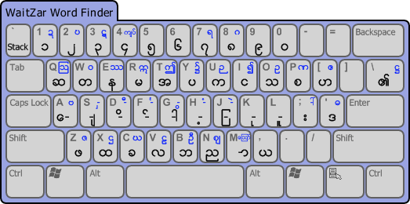
…we can see that pressing “U” will type “က”. The letters in blue are the shifted Burmese letters for each key; if you hold down “Shift”, then you will see them swap places with the black letters:
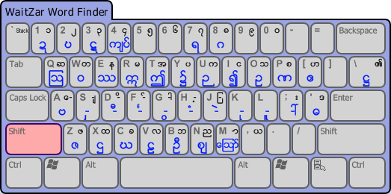

So, typing shift+u will type “ဉ ”, not “က”. When you are looking up a word, make sure to type the consonant before any vowels, medials, or tone marks. So, in order to type “လေး”, we type the letters in this order:
Burmese Letters: လ ေ း
Actual Keys: v a ;
At this point, WaitZar has identified the word for us, and we can press “space” to enter it into our sentence window:
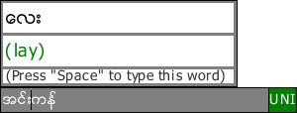

Unicode keyboard users should be able to figure this out pretty easily. Note that, due to advances in Unicode technology, WaitZar’s keyboard doesn’t require any difficult key sequences such as Ctrl+Shift+Key or Alt+number. Only the Shift key is used to extend the letter base. For example, instead of having a “stacked” letter for each consonant, just type “`” after the consonant to stack it. So, to look up “waitzar”, we type:
Burmese Letters: ဝ ိ ဇ ဇ(stack) ာ
Actual Keys: shift+w d shift+z shift+z ` m

Even if there is no romanisation for a given word, you can still press “Space” and type it. This is the best way to add a word to mywords.txt —just type it using the WaitZar help keyboard!

You can press “Esc” or “F1” to cancel the help keyboard. The “Memory List” to the right of the virtual keyboard will store your most-recently looked-up words, for quick reference:
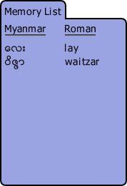

5. Advanced Usage

Wait Zar can be customized to suit your needs. For example, many programmers use “Ctrl+Shift” to select rows of text. They may want to change the language hotkey to “Alt+Shift” —but anyone typing in Chinese will prefer to change it to something else (“Ctrl+Space” maybe). A great deal of configuration options will be available to Wait Zar users. This section details some of them.
In order to apply any of these custom configurations, you must unzip WaitZar.exe into a directory. You cannot just run it from within the zip file. You should also unzip config.txt and mywords.txt, although this is not strictly necessary.

5.1 Changing the Hotkey

The hotkey is just another option, but changing it is the most common request we get. To do this, go to the directory you unzipped WaitZar.exe into. Look for the file “config.txt”. If it doesn’t exist, create it, open it in Notepad (not Wordpad) and add the line:
hotkey = ^m
This will set the hotkey to control m. If config.txt does exist, open it and look for the line:
hotkey = ^+
…and change it to
hotkey = ^m
…this will change the hotkey. The “^” symbol is a “modifier” and the “m” is the “letter” to trigger the hotkey. Wait Zar will always use the last character as the “letter” and all other letters as modifiers. So, if you type:
hotkey = ^^
…then, presumably, one would have to hold “Ctrl” and press “Ctrl” to trigger Burmese. (This will probably just set the hotkey to “Ctrl”… it’s kind of an odd hotkey, really.) The following modifiers are allowed:
^ is for Ctrl
! is for Alt
+ is for Shift
Any character is allowed for a letter, and any modifier can also be a letter. In addition, some “untypable” letters are allowed:
_ is for Space
Please note that, due to the nature of hotkeys under Windows, you should use lower case letters whenever possible. If you set:
hotkey = ^M
…then the hotkey will actually be set to “Ctrl+Shift+m”, because you need to hold down the shift key to type a capital M.
Note: We highly recommend that you don’t use shift+letter (or just letter) for the language hotkey, as this will conflict with that key being used to type Burmese, and you will get an error message upon switching to Myanmar. A similar error will occur if you try to set the hotkey to one of the keys used by the help keyboard (“~”, for example).
If you aren’t sure what the current hotkey is, simply right-click on the system tray icon:
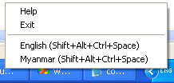

5.2 Configuration Options

To configure Wait Zar, you should edit the file “config.txt”. This file should be present in the same directory as WaitZar.exe; if you don’t have it, you can create it yourself, or just unzip it from the Wait Zar download for the current release.
The config file consists of lines structured as:
name = value
…where “name” is a single word composed of english letters, and “value” can be any number of things, depending on name. The following table lists all configurable options available at the moment. If your config.txt file does not contain a certain option, its default value will be used. If you mis-type a name, it will simply be skipped.
Please note that all names are case sensitive. If you type “Hotkey = ^m”, the system will not recognize that you entered a valid option.

5.2.1 Standard Options

The following options are the most meaningful; there is a very good chance that you will have to change one of them to customize WaitZar to your needs.
Name | Value | Meaning | Default
hotkey | [modifier] letter, where modifier is:  ^ for Ctrl  ! for Alt  + for Shift  …and letter is any of these, or:  _ for Space  …or any letter. | Set the “switch language” hotkey. Use this if the default hotkey conflicts with some other task on your system. Example:  hotkey = ^m  …sets the hotkey to Ctrl+m | ^+
ballooononstart | Either of the following:  yes  no | If yes, WaitZar will show a “welcome” balloon in the system tray when it first launches. | yes
trackcaret | Either of the following:  yes  no | WaitZar tries to put the sentence window where you are currently typing. If you find this annoying, set this option to “no” and drag the window where you want it to stay. | yes
defaultencoding | Either of the following:  unicode  zawgyi  wininnwa  Also:  padauk  parabaik  myanmar3  …mean the same as “unicode”. | Sets which encoding Wait Zar will use when it first loads. Set it to zawgyi or wininnwa if you use these fonts, and leave it as “Unicode” otherwise. | unicode
burmesenumerals | Either of the following:  yes  no | If yes, then 0-9 will type Burmese ၀-၉. | yes

5.2.2 Advanced Options

These options are less common; you should only change them if you really know what you are doing.
Name | Value | Meaning | Default
alwayselevate | Either of the following:  yes  no | Some Vista Home Premium users will get constant errors from WaitZar. Change this to “yes”, and WaitZar will always ask you to run it as an administrator. | no
lockwindows | Either of the following:  yes  no | If no, the sentence window can be disconnected from the main window. Only applies if powertyping is yes. | yes
ignoremodel | Either of the following:  yes  no | If yes, we do not load the embedded file Myanmar.model, and instead only load words from mywords.txt. (See Section 5.5) | no
charaset | Either of the following:  myanmar  burmese  any | If set to “myanmar” or “burmese”, then entries in mywords.txt must contain only Burmese letters. This allows us to use the Help keyboard even on words added by users. If set to “any”, the help keyboard is disabled, and any letter can be used for custom words. (See Section 5.5) | myanmar
fontfileregular | Any file name, or “default” or “embedded” to use the default (embedded) Zawgyi font. | Set to a file name to use this font for WaitZar’s entry window. Fonts must conform to the PulpCore standard. (See Section 5.5) | Default
fontfilesmall | Any file name, or “default” or “embedded” to use the default (embedded) Zawgyi font. | Set to a file name to use this font for WaitZar’s sentence window. Fonts must conform to the PulpCore standard. (See Section 5.5) | Default

5.2.3 Deprecated Options

The final set of options are deprecated; they were introduced at a development crossroads some time in WaitZar’s past, and they make little sense in the latest versions. Although these options are still supported, you should not change them barring exceptional circumstances —they might be removed in the future.

Name | Value | Meaning | Default
mywordswarning | Either of the following:  yes  no | User-defined words are fully-tested, but you may choose to leave this to “yes” to show a warning if a custom dictionary is used. | No
powertyping | Either of the following:  yes  no | If no, “space” will type each word directly, bypassing the sentence window. We highly recommend setting this to yes. | Yes

5.3 Changing the Font

Most new fonts will work with Wait Zar; Unicode 5.1 was a huge improvement to the Myanmar language in this regard. However, two older fonts are used widely in Myanmar publications and blogs, and are also supported by Wait Zar for legacy reasons.
While Wait Zar is running, right-click on the tray icon and choose “Encoding” to see the following:
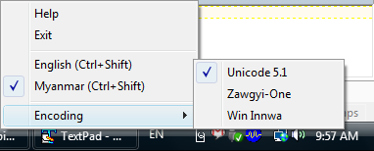
Click on Zawgyi-One or Win Innwa to change the output font. Now you can type in that font as well! To easily tell which language you are typing in, look on the right-hand side of the sentence window. “ZG” is for Zawgyi-One, “WI” is for Win Innwa, and “UNI” is for Unicode output:
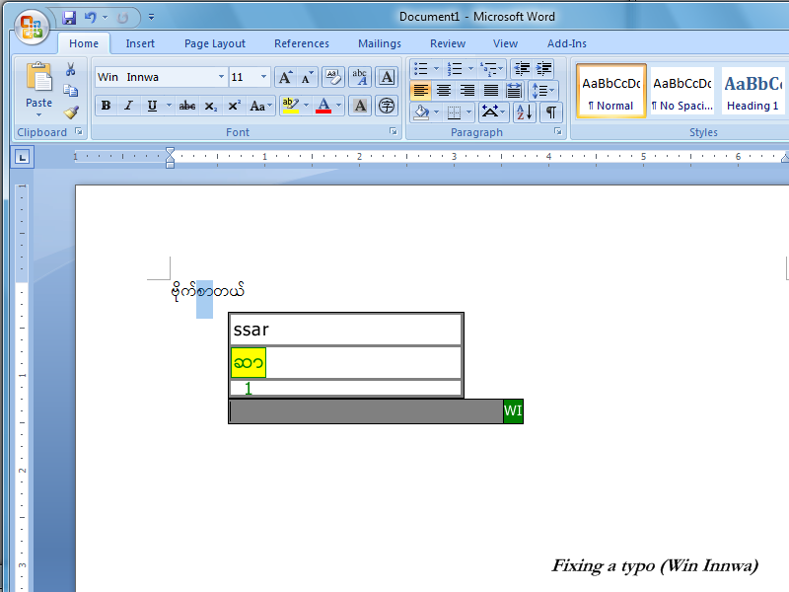
NOTE: You will still have to change the font in Microsoft Word. Also, Wait Zar will always display text internally using the Zawgyi-One font.

5.4 Adding Your Own Words

If you need to type a word that WaitZar doesn’t know about, you should edit the file “mywords.txt”. This file should be present in the same directory as WaitZar.exe; if you don’t have it, you can create it yourself, or just unzip it from the Wait Zar download for the current release.
NOTE: If you create this file yourself, make sure you save it in the UTF-8 encoding.
NOTE: When editing this file, do not use Wordpad. You should use Notepad, because Notepad will preserve the encoding. If you use Wordpad, it will change all your Burmese letters to “????”
The file mywords.txt consists of pairs of the following:
myanmar = roman
…where “myanmar” is a word in Burmese, and “roman” is its romanisation. Note that “roman” should consist of all lowercase letters. Also note that “myanmar” should be written using the Zawgyi-One font. (We will change this later to be more universal.) The best way I’ve found to do this is to type the “myanmar” word in Microsoft Word, then copy-paste it into Notepad. You’ll see it as boxes, but it’ll work correctly.
For example, if you want to enter the word “အ” as “ah” instead of “a”, you can add the line:
အ = ah
You can also enter shortcuts. For example, to type “ဗိုက်ဆာတယ်”, you currently have to type “vite” “ssar” “tal”. But this is a common phrase, so you might add:
ဗုိက္ဆာတယ္ = vitessartal
…to the dictionary. You might even add:
ဗုိက္ဆာတယ္ = hungry
…if you want to. Note that only letters which fit in the range [a-z\u1000-\u109F] (e.g., Burmese and English alphabets) are currently supported, for reasons of security. You can override this restriction in config.txt by setting “charaset” to “any”.
NOTE: If you receive an error that says you have “Too many custom words!” (or “nexi” or “prefixes”) then this means you should remove some entries from mywords.txt, or adjust the various “size” options in config.txt. There’s almost no reason to have this many custom words, however.
If you find Burmese words that aren’t in Wait Zar, please report them at: http://code.google.com/p/waitzar/issues/list; we’ll add them to the default model for the next release. Thanks!

5.5 Loading a Completely Different Language

WaitZar is optimized for Burmese; however, you can actually use it for any language. This is very useful if you are developing a new romanisation, and you want to test it out quickly on a real computer. It is not recommended for big languages (loading a font with every CJK ideograph will crash the system, for example). Here, we will describe how to load a custom dictionary in WaitZar.
The first step is to skip loading the Myanmar model. To do this, open config.txt and set “ignoremodel” to “yes”. If you ran WaitZar now, you would not be able to type any words at all!
Next, you will want to create a new mywords.txt file that contains all of your mappings. This file should be encoded in UTF-8. Enter each word/syllable on one line, with the native word on the left and the romanised form on the right. For example:
你好 = nihao
The next step is to optionally change the “charaset”. Whenever possible, try to keep this set to “myanmar". For example, if you are trying to write a custom dictionary for Romabama or Burglish, you would set “charaset = myanmar". If you were trying to write one for Korean or Shan, you should set “charaset = any”.
After this, try to run WaitZar. Unless you have an absurd number of dictionary entries (sizeof(unsigned int) on most platforms), it will start up just fine. Note that it might, however, take some time to do so.
Finally, if your romanisation does not map to the Zawgyi-One font, then you’ll have to set “fontfileregular” and “fontfilesmall” to the names of the files you’ll use for your language. The files “chinesefont.png” and “chinesefontsmall.png” are included with the source as examples. These are not just ordinary PNG files, however —they have several special chunks defined by PulpCore. The Java file com.waitzar.utility.PNGReCoder is included with the source to help you create this type of file. Please contact the developers if you’re having trouble with this; we’d be happy to offer some advice.
Here is a screenshot of WaitZar running with a subset of the Chinese language loaded and a custom font. As you can see, it is missing a lot of important words:
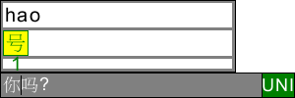

5.6 Running Wait Zar from a USB Drive with PStart

If you copy Wait Zar to a USB drive, it will work just like normal! Take Wait Zar on the go! However, if you want a really good setup, consider using PStart. Here’s how:
- Download PStart (the normal one, not U-3) from: http://www.pegtop.de/download.php?file=start
- Make sure your USB drive is plugged in, and run the PStart setup file. When you get to the “Setup Type”, choose “Portable Setup”, and select your USB drive’s letter.
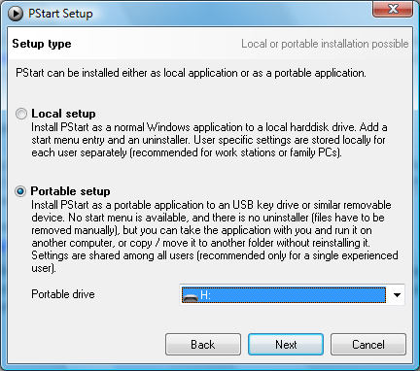
- Now, browse to your USB drive. Make a folder called “waitzar”, and extract the Wait Zar files there. Here’s a snapshot of my USB drive (with some extra folders & files)
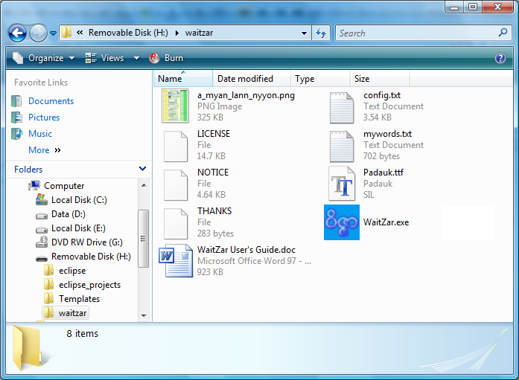
- Now, go to the root folder of your USB drive and click “PStart.exe”. When the PStart window shows, click “Edit” then “Add File”. Browse to the “waitzar” folder we created in step 3, and double-click “WaitZar.exe”. A new window will pop up… click “Ok”. Now, close the PStart window.
- As long as PStart is running, you can click on its icon in the system tray and choose “WaitZar” to launch WaitZar. You can add many other programs to PStart, and get a fully-functional mini Start Menu on any computer you connect your USB drive to!
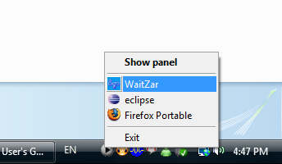

6. Troubleshooting FAQ

Here are some problems our users have run into and their solutions:
Q: When I type in Google Talk, all I see are boxes.
A: Make sure you set the font for Google Talk itself. Click on “Settings” and go to “Choose Font”. If this still doesn’t fix things, make sure you are typing in English (with a US keyboard layout). For example, one user reported problems using WZ while the language was set to Chinese. Switching back to English solved the problem.
Q: I typed a word, and now I can’t delete part of it.
A: This is a common occurrence if you type a word with asat “—္” and then hit “backspace”. Sometimes, the asat is after the cursor, although it appears before it. Try hitting the right arrow key, and then backspace. This is an issue with all Burmese fonts in programs that do not fully support Burmese text.
Q: Help! Wait Zar doesn’t work with Open Office!
A: For some reason, Open Office under windows neglects to detect Burmese code points —for some users, it switches to “Tahoma” even if you select Zawgyi-One. The big problem with this is that it will make all Burmese characters invisible, and of zero length! To fix this, after typing hit “Ctrl+A” to select everything and change the font to Zawgyi-One. After this, you should be able to type using Wait Zar without switching the font.
Note: Hopefully, this will be fixed with the addition of the Burmese locale in Open Office 3.1. Can anyone confirm this?
Q: Help! I can’t use Wait Zar during a webcam conversation on MSN.
A: Certain parts of WaitZar (esp. the System Tray icon) will slow down dramatically on heavily-loaded systems. However, it should be possible to type effectively. If typing is impossible, make sure your system has enough virtual memory, and scan for viruses. Also, click and drag the WaitZar window so that it does not cover the webcam feeds. This might help.
Q: (Some word) won’t look correct in Win Innwa or Unicode…
A: Each word was hand-checked for errors. Please see section 6.1 for known errors. Also, it’s important to remember that Myanmar’s Unicode encoding has been fluctuating for several years. Make sure you have the latest font from the developer’s web site. Finally, if you enter your own words, there is a small possibility that they will not convert correctly. Please post a bug report if this happens to: http://code.google.com/p/waitzar/issues/entry

6.1 A Note About Windows 7

At the time of WaitZar 1.7’s release, Windows 7 was not yet fully stable. As such, we do not officially support Windows 7. However, we’ve done a small amount of testing, and confirmed that WaitZar does indeed work on Windows 7, with a few limitations.
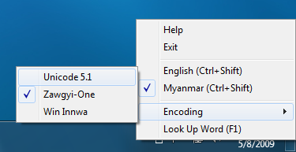
First of all, Windows may hide the WaitZar tray icon. You will have to enable both “Notifications and Icon” to see the WaitZar icon.
Second, when typing on certain windows (such as the desktop) which do not contain a caret, WaitZar may appear on the top-left corner of the screen. You will have to drag it to center of the screen. Fortunately, you are unlikely to encounter this scenario, since you will usually be typing only when there is a caret anyway. As you can see, WaitZar lines up fine in Word Pad, and can output Burmese text with no problem:
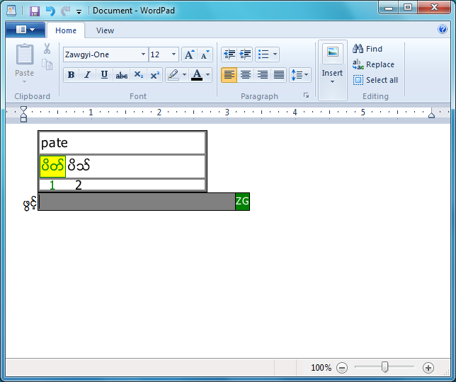
In conclusion, WaitZar works fine on Windows 7, but it is still not officially supported. We will add this support in the future, after Windows 7 is released.

6.2 Known Font Issues

This section requires the Zawgyi-One font to render properly.

Unicode 5.1 is still somewhat new, and there are a few glitches in fonts which support the latest standard. When possible, Wait Zar will re-organize the letters in a word to hide these errors. However, this is not always possible. Please be aware of these errors. If you are a font developer, we’d love to hear from you —give us an email and we’ll offer whatever suggestions we can.
We apologize if any of these words are considered “incorrect” by a font developer; we will remove them from the dictionary if you can give us sufficient examples of words to use in their place. (We have already done this for several words, after excellent feedback from the Padauk developers).
Sequence (Zawgyi-One) | Encoding (Unicode 5.1) | Problem | Solved?
ေယာကၤ်ား | \u101A\u1031\u102C  \u1004\u103A\u1039  \u1000\u103B\u102C  \u1038 | Parabaik has trouble with this sequence. | Requires font modification.
လက်ာ္ | \u101C\u1000\u103B  \u102C\u103A | Myanmar3 cannot attach “—္” correctly to “ာ”. | Requires font modification.
ဆြိ႕ | \u1006\u103D\u102D  \u1037 | Myanmar3 cannot attach “—႕” correctly to “—ြ”. Switching “—ြ” and “—ိ” doesn’t help. | Requires font modification.
ၫႈိး | \u100A\u103E\u102D  \u102F\u1038 | Myanmar3 and Parabaik display short “—ု” as tall “—ဳ”. Re-ordering doesn’t help. | Requires font modification.
ညဳ | \u100A\u102F | Padauk displays this (in any form) with short “—ု” instead of tall “—ဳ”. | Requires font modification.
ႏူိက္  (Also occurs for: ႏူိင္) | \u1014\u102D\u1030  \u1000\u103A | Myanmar3 and Padauk do not render “—ူ” in the right location. Parabaik and Myanmar3 both fail to shorten “န” to its short form “ႏ”. Switching “—ူ” and “—ိ” doesn’t help. | Requires font modification.
မႉး | \u1019\u103E\u1030  \u1038 | Myanmar3 and Parabaik render short “—ူ” as tall “—ဴ”. Switching the encoding order doesn’t help. | Requires font modification.
မုဴိး  (Also occurs for: မွဴး) | \u1019\u102D\u102F  \u1030\u1038 | Myanmar3 and Parabaik encode tall “—ဴ” as short “—ူ”. Switching the encoding order doesn’t help | Requires font modification.
ရွဴ and ရွဴး | \u101B\u103E\u1030 (opt:\u1038) | Padauk converts tall “—ဴ” to short “—ူ”. | Requires font modification.
လွဴ | \u101C\u103E\u1030 | Padauk converts tall “—ဴ” to short “—ူ”. | Requires font modification.

6.3 Contacting the WaitZar Team

If you need help with WaitZar, or if you have any suggestions or feedback, please contact us:
http://www.waitzar.com/contactus.py

Appendix A: License

Wait Zar is licensed under the Apache License 2.0; see the file LICENSE for more information.
This means that Wait Zar is open source, so you can always modify it and redistribute it as long as your comply with the license. For example, if you wanted to use the code to write a MacOS plugin, you could do that. Of course, we’d like to hear about all projets like this on the mmgeeks forum: http://mmgeeks.org/
More importantly, Wait Zar is open source so that you feel like you can get involved. We’d love to hear from you; your experiences with the program, any suggestions, or any new words you’ve found. Again, the mmgeeks forum is where all the discussions about Wait Zar take place.

